Implement programs for visualizing time series data

**AIM:**

To implement a program for visualizing time series data.

**PROCDURE:**

*Step 1: Install Required Libraries*pip install pandas matplotlib seaborn plotly bokeh

*Step 2: Load the Dataset*import pandas as pd

# Load the dataset

url = "https://raw.githubusercontent.com/jbrownlee/Datasets/master/daily-min-temperatures.csv"

df = pd.read_csv(url, parse_dates=['Date'], index_col='Date')

# Display the first few rows

print(df.head())

*Step 3: Explore the Dataset*

# Check for missing values

print(df.isnull().sum())

# Check date range and frequency

print(f"Date Range: {df.index.min()} to {df.index.max()}")

print(f"Frequency: {pd.infer_freq(df.index)}")

*Step 4: Visualize the Data*

*Option 1: Using matplotlib*

import matplotlib.pyplot as plt

# Plotting

plt.figure(figsize=(12, 6))

plt.plot(df.index, df['Temp'], label='Daily Minimum Temperatures', color='orange')

plt.title('Daily Minimum Temperatures in Melbourne (Matplotlib)')

plt.xlabel('Date')

plt.ylabel('Temperature (°C)')

plt.legend()

plt.grid(True)

plt.show()

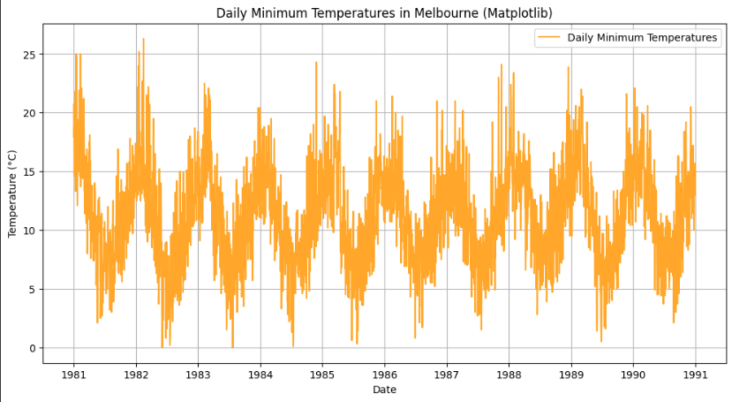

*Option 2: Using seaborn*

import seaborn as sns

# Plotting

plt.figure(figsize=(12, 6))

sns.lineplot(x=df.index, y=df['Temp'], label='Daily Minimum Temperatures', color='purple')

plt.title('Daily Minimum Temperatures in Melbourne (Seaborn)')

plt.xlabel('Date')

plt.ylabel('Temperature (°C)')

plt.legend()

plt.grid(True)

plt.show()

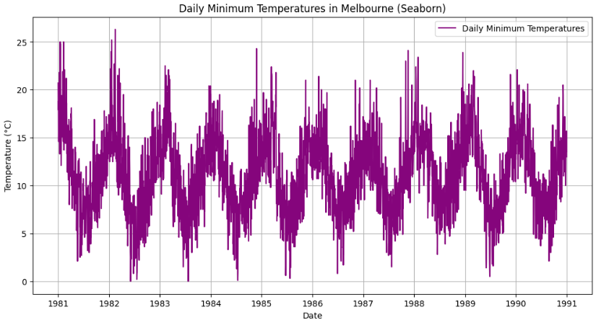

*Option 3: Using plotly*

import plotly.express as px

# Plotting

fig = px.line(df, x=df.index, y='Temp', title='Daily Minimum Temperatures in Melbourne (Plotly)')

fig.update_xaxes(title_text='Date')

fig.update_yaxes(title_text='Temperature (°C)')

fig.show()

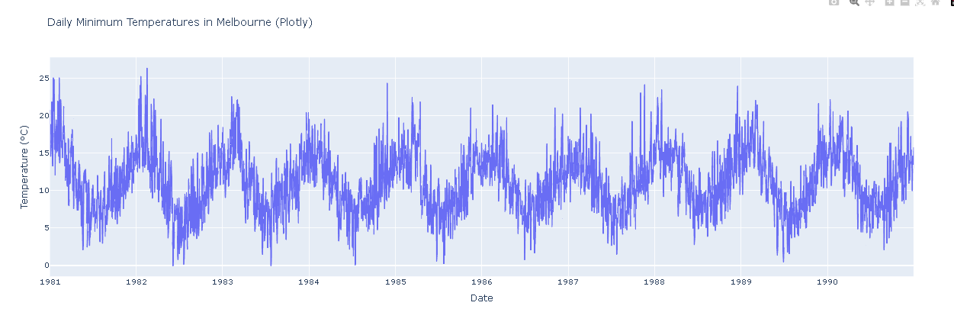

*Option 4: Using pandas built-in plotting*

df.plot(figsize=(12, 6), title='Daily Minimum Temperatures in Melbourne (Pandas)', grid=True, legend=True, color='green')

plt.xlabel('Date')

plt.ylabel('Temperature (°C)')

plt.show()

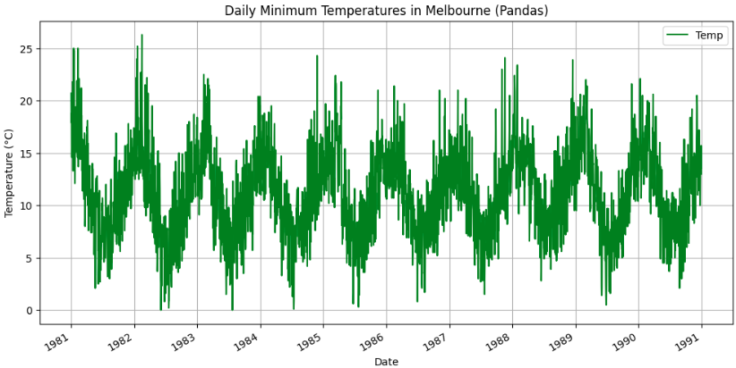

*Option 5: Using bokeh*

from bokeh.plotting import figure, show

from bokeh.io import output_notebook

# Enable Bokeh for Jupyter Notebook

output_notebook()

# Plotting

p = figure(title="Daily Minimum Temperatures in Melbourne (Bokeh)",

x_axis_label='Date', y_axis_label='Temperature (°C)',

x_axis_type='datetime', width=800, height=400)

p.line(df.index, df['Temp'], legend_label='Daily Minimum Temperatures', line_width=2, color='red')

show(p)

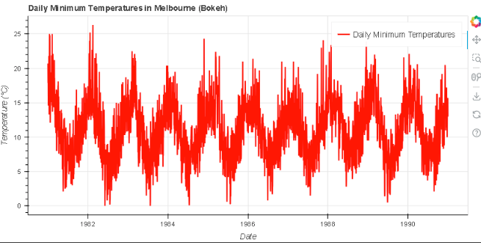

**RESULT:**

Thus the program to visualize the time series data has been done successfully.